*Embargoed until 7. June 2024*

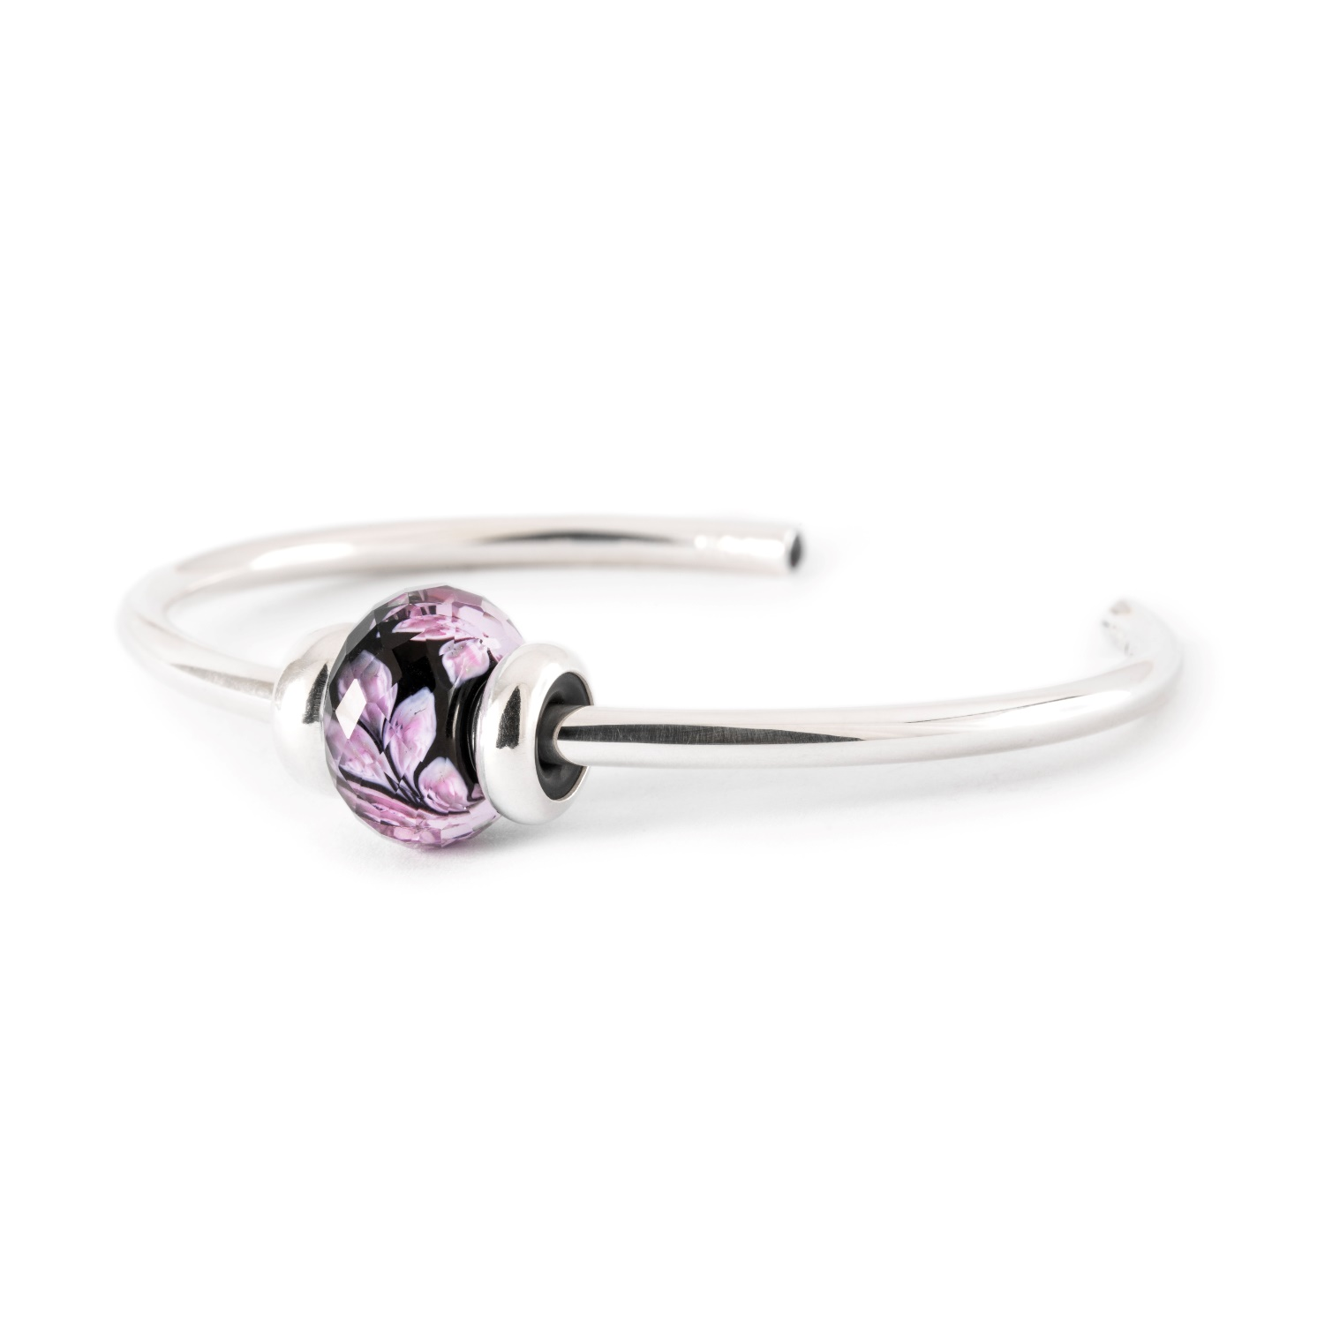

**Power Bangle: Elegance Meets Emotional Balance**

**Introducing Trollbeads' latest masterpiece – the Power Bangle.**

Experience the allure of bright sterling silver adorned with facetted amethysts at both ends. Whether worn boldly with an array of beads or kept sophisticated with a few select ones, this bangle graces the wrist with elegance and versatility.

Amethyst is cherished for its healing properties, promoting emotional balance, spiritual clarity, and inner harmony. It’s a perfect companion for those seeking tranquillity.

**Limited Edition Amethyst Serenity Bangle**

Together with the Power Bangle, the limited edition Amethyst Serenity Bangle, featuring an artisan, handmade glass bead, is also released. Embrace the empowering essence of amethyst and the serene energy of delicate pink petals and revitalize your inner strength.

*#PowerBangle #AmethystSerenity #PowerJewellery #DiscoverTrollbeads*

Prices:

Power Bangle: **€ 109.**

Amethyst Serenity Bangle, limited edition: **€ 129.**

The collection is available in stores and online from **5. July 2024**

**For further information, high resolution images etc., please contact:** Insert local PR contact